Lab 5: Stream editor - sed 1%

- Answer all of the following questions. Questions are given in bold italics.
- Save all your answers in a file named YourFirstNameYourLastName.doc (or the appropriate file extension).
- Upload this file to Blackboard.

- Create a directory called Lab5 in your home directory.

Note: Remember Linux is case sensitive.
What is the command you used to create this directory?

- Write a sed command that replaces all occurrences of the pattern MACBETH (case sensitive) in the file /macbeth.txt with your surname.

The output should print to the shell.
Sed –e’s/MACBETH/MEAGHER/G’ Macbeth.txt

- Write a sed command that deletes all lines beginning with either T or t in the input.

The output (non-empty lines) should print to the screen.
Use the file /sedTest.txt for testing.
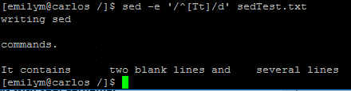

- Write a sed command that deletes all empty lines in the input.

The output (non-empty lines) should print to the screen.
Use the file /sedTest.txt for testing. (Hint: try ‘/^$/d’ )
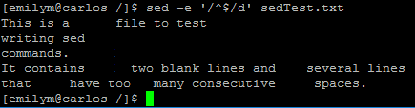

- Write a sed command that substitutes a single space for any number of consecutive spaces occurring on a line.

The output should print to the screen. Use the file /sedTest.txt for testing.
(Hint: try ‘s/ */ /g’ )

Turn over page for question 6
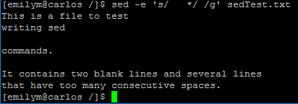

- The contents of the file /speeling.txt contains a number of spelling errors. The correct spellings are given in /speeling_corrected.txt.

Write a script which corrects all of the spelling errors present in the /speeling.txt file.
Create the script in your Lab5 directory and name the script spellFixer.sh.
List the contents of this script.

Note:
- Your script should prompt the user to enter the name of the input file (the file whose spelling mistakes are to be fixed).
- Your script should then prompt the user to enter the name of the output file (the file to store the corrected version of the input file).
- Then your script should fix each of the spelling errors present in the input file and store the ‘fixed’ text in the output file.
- Example:
$ ./spellfixer.sh
Enter the name of the input file:
/speeling.txt
Enter the name of the file to output:
~/Lab5/spelling_fixed.txt
$ cat spelling_fixed.txt
Hi, my friend and I are going to the cinema tonight.
Would you like to come with us?
We would really like you to come tonight.
$

